Special Agent Fred Bradford
Private Sector Coordinator for the Las Vegas Division of the FBI
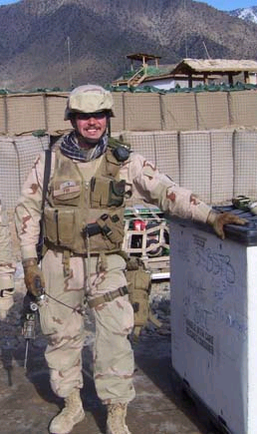
Has worked foreign counterintelligence and espionage investigations with the FBI since 2002. He is currently the lead liaison for National Security Investigations in Nevada. He joined the FBI in 1999 and first worked criminal and international terrorism investigations.
He was recently assigned as the Acting Assistant Legal Attache’ to the U.S. Embassy in Ankara, Turkey and the U.S. Consulate in Istanbul.
Served as a Supervisor at FBI Headquarters from 2008 to 2010 managing FBI counterintelligence operations for several Middle East countries.
Deployed to Afghanistan in 2006 where he was imbedded with a U.S. Army Special Forces team in Eastern Afghanistan.
Deployed to Kuwait and Iraq in 2003 for Operation Iraqi Freedom serving with an FBI team imbedded with U.S. Army intelligence - he helped establish the first FBI station in Iraq.
Served in the U.S. Navy aboard the aircraft carrier MIDWAY from 1986 to 1990 as an Engineering and Navigation Division Officer.
Private sector experience working for U.S. companies in Taipei, Seoul and Perth.
MBA – University of Queensland
BA – University of Michigan

