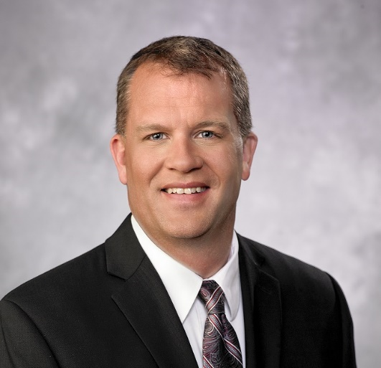
DAVID L. JOHNSON
DEPUTY GENERAL MANAGER - OPERATIONS
LAS VEGAS VALLEY WATER DISTRICT
SOUTHERN NEVADA WATER AUTHORITY

David L. Johnson is the Deputy General Manager of Operations for the Las Vegas Valley Water District and Southern Nevada Water Authority. He has been with the agency since 2004. Mr. Johnson holds a Bachelor’s degree in chemical engineering from Purdue University and has close to 30 years of management experience in chemical manufacturing, water treatment and water quality. He serves as Chairman of the Board for Nevada’s WaterStart and participates on other related boards and committees.

