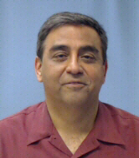
Zach moved to Las Vegas from New Jersey in 1996 after working in the private sector as a General Contractor for 25 years. Upon arriving in Las Vegas he worked for various local developers as a Project Manager before joining the Building Inspections Department with City of Las Vegas for a year in 2000. He transitioned to the Clark County Building department in 2001 as a Building inspector I.

His background in Management and commitment to continual training for certifications for different trades allowed him to work his way up the ranks to Sr. Building Inspector and Supervising Building inspector in 2005. He continued his studies and eventually earned Certified Building Official credential. Zach was promoted to Inspections Manager in 2015. Currently, he manages the inspections for the AFP inspection process in the resort properties. Throughout his 14 years of supervising building inspections, Zach has had the opportunity to work with many of the resort properties for the building inspection process and has developed excellent relationships with many of them.

